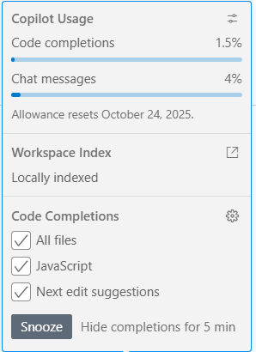

Copilot Usage

Code completions1.5%
Chat messages4%
Allowance resets October 24, 2025.

Workspace Index

Locally indexed

Code Completions

All files
JavaScript
Next edit suggestions
Hide completions for 5 min

